**IoT based Beehive monitoring for Effective Honey Production**

**Abstract**

The decline in global bee population poses an impending threat to ecosystems and agriculture, pinpointing the need for innovative solutions to monitor and manage beehives successfully while also increasing the production of honey from them. This paper aims to introduce a real-time bee monitoring system using IoT to address this. The proposed system integrates sensors, machine learning and communication protocol to provide real-time insights into the health and productivity of the bee colonies.

The sensors used here collect data on parameters like temperature, humidity, hive weight, sound, Vibration and gas sensors. These sensors are connected to a central hub, which utilizes IoT protocols to transmit data to a cloud-based platform for storage and analysis. Advanced analytics algorithms process the collected data, offering beekeepers valuable information about hive conditions, potential stressors, and overall colony well-being.

1. **Introduction**

Beekeeping plays a pivotal role in agriculture, pollination and more importantly honey production. However, the challenges faced in the beekeeping industry have been increasing at an alarming rate over the years. These challenges include, but are not restricted to adverse impacts due to climate change, prevalence of diseases, the harmful chemicals in the pesticides sprayed on crops, and many more. To address these issues, it is imperative to harness the new age technologies available. The primary objective of this research is to empower the beekeepers by providing them with real-time data which opens up new avenues for Apiculture management which in turn helps increase productivity and manage the health of the beehive.

1. **Literature Survey**

IoT based Beekeeping Systems: Various IoT based systems for beekeeping have been proposed. These monitor parameters like temperature, humidity, weight, sound and more. Kontogianni introduced a system that uses Wi-Fi or GSM for data transmission in India. Kozloski utilized IoT along with machine learning for transmitting data via WiFi or Gsm. However, these systems suffer from high power consumption and are complex to install. They mainly focus on parameters that address these concerns while providing a cost-effective, low-power, long range system which is focused on temperature and humidity.

Beemon: An IoT-Based Beehive Monitoring System by Tashakkori et al. is designed to collect sensory data and audio or video recordings for remote analysis from beehives. It addresses the challenges associated with labor-intensive manual hive inspection and limitations of existing automated systems. Beemon includes a Raspberry-Pi, load cell, DHT22 sensor, microphone, camera, ThingsBoard dashboard, and a remote server for analyzing the data collected. The system highlights the need for robust algorithms and high quality data to analyze the behavior of beehives.

IoT-Based Monitoring and Prediction for Honeybee Activity tackles the grave issue of bee extinction. It provides a thorough survey of beekeeping methods, evaluating the numerous technologies used to measure the crucial parameters affecting bee health. The system proposed includes a modular base station, cloud server, web application, IoT sensors along with Artificial Intelligence. It makes use of timer series forecasting models like LSTM and GRU to predict the entry and exit of the bees based on environmental conditions. The system also incorporates an analytical alarm system for anomaly detection in sensor data, offering predictive and analytical alerts to beekeepers.

Mayack et al. in "Poor Air Quality Is Linked to Stress in Honeybees and Can Be Compounded by the Presence of Disease" explores the impact of climate change-related stress on honeybee health in California. The study, conducted in wildfire-prone areas, reveals that elevated temperatures and poor air quality correlate with reduced colony growth, increased pest and pathogen loads, altered gene expression, and impaired organ function in honeybees. The findings contribute significantly to the existing literature on climate change's effects on pollinators, emphasizing the understudied link between air pollution, specifically from wildfires, and honeybee well-being. This paper identifies a gap in previous research, expanding our understanding of the molecular and physiological mechanisms governing honeybee responses to environmental stressors. Despite these contributions, the study has limitations, such as relying on the Air Quality Index as a sole measure for air quality. The authors suggest future research should delve into the diverse components of particulate matter and gasses emitted during wildfires, considering their potential differential impact on honeybees. Additionally, the study lacks exploration into other influencing factors like nutrition, genetics, and landscape characteristics. The absence of long-term effects analysis and comparisons with other pollinators also provides avenues for further investigation.

In the paper ‘Modelling daily weight variation in honey bee hives’ by Arias-Calluari et al they aim to enhance understanding of bee colony dynamics through a combination of theoretical modeling and statistical analysis of intra-day weight variations. The authors propose ordinary differential equations describing hive weight changes based on factors like forager count, collected food, and evaporation rate. They employ a Bayesian approach to estimate model parameters from single-day measurements.

The paper contributes to honey bee colony dynamics literature by offering a simple method to glean hive state information from weight measurements. It acknowledges and builds upon previous studies on hive weight data's use in inferring bee foraging activity, highlighting limitations in existing methods. While relating to mathematical modeling literature on bee colonies, the paper distinguishes itself with a less complex model, claiming to capture essential daily hive dynamics without excessive assumptions.

To validate the model, the paper applies it to 10 hives at various times and locations, demonstrating good data fit and consistent parameter estimates. The discussion delves into potential applications, such as early warning indicators for colony failure based on foraging success and active foragers. The paper suggests future research directions, including incorporating additional factors like brood rearing, swarming, and robbing into the model.

1. **Problems Addressed**

In apiculture, an optimal practice involves employing around 200-300 boxes. Checking each box for honey, disease or swarming is time consuming and difficult for the beekeepers. Bees collect nectar from plants and share it with other bees to make honey in the frames. If from the nearby agriculture field it collects pesticides, it has a negative impact on the health of the honey bee as well as the quality of honey. If not detected earlier, the bees end up dying within days. If it is detected, the unaffected bees can be shifted to a new frame. Moreover, checking the boxes everyday to see whether honey is formed also consumes a lot of time.

During winter, bees prefer to not leave their hives due to the harsh climate, and therefore end up being weak. Beekeepers provide sugar syrup which acts as an energy source for them. This also boosts honey production.

In order to analyze the swarming rate, humidity, temperature and air quality inside the hive is monitored round the clock. Analyzing weight of the bee hives help us in estimating the bee count, swarming and honey production. Motion sensors are also planned to be used to alert the beekeepers of the possible theft of the boxes by bears.

1. **Block Diagram**

**Estimated Prototype Implementation**

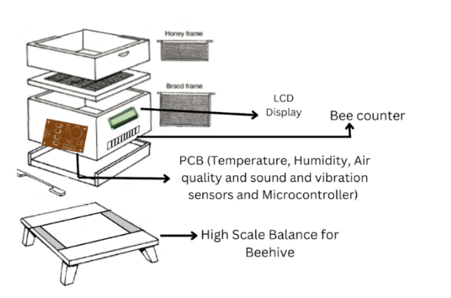

1. **Protocol used**

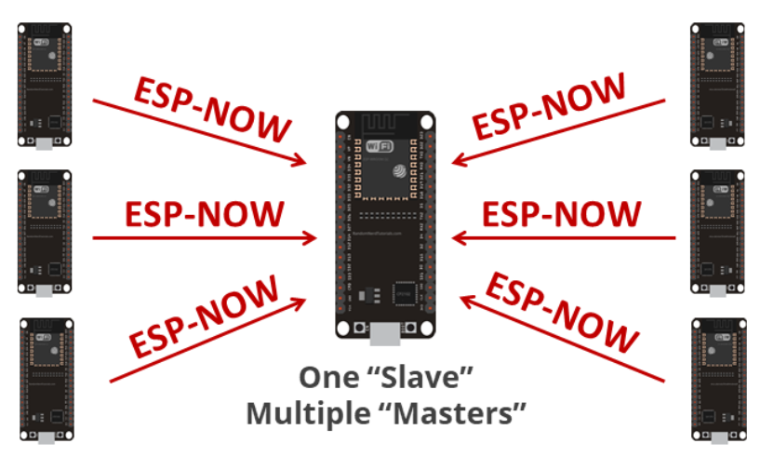

In our proposed system, we intend to implement a "one slave, multiple master" communication protocol using ESP32 boards. Each of the boxes will be fitted with an ESP32, serving as a slave device. All the slave devices are connected to a “master” ESP32 device which communicates with them using ESP-NOW protocol.

This architecture allows for seamless data exchange between master and slave devices ensuring efficient and reliable data transmission among the beehive boxes.

The master ESP32 aggregates and analyzes data from the slave ESP32 using the pre-trained ML model. This allows it to extract valuable insights from the collected data. All the collected data is displayed on the display board installed outside individual bee boxes. This allows for the beekeeper to be informed about hive.

**Results**

Partially Implemented.